Week #10

Create class Person………...class which will display name, address and date of birth of a Person object.
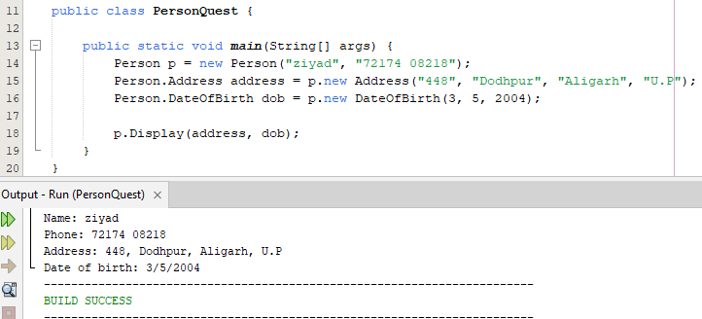
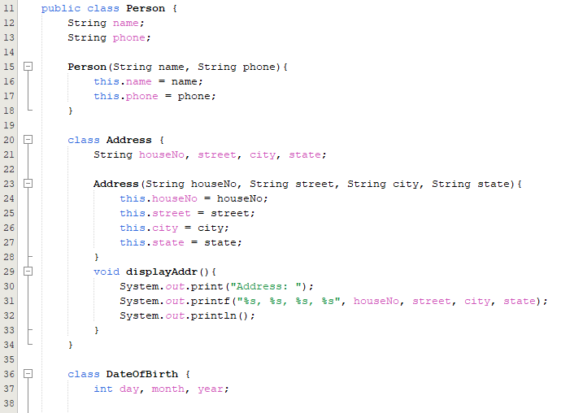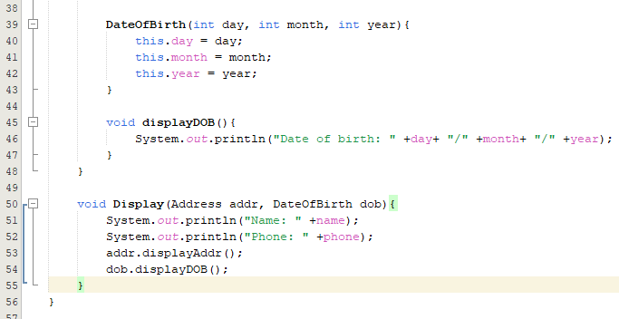

Create class Edible……………vegetablePackaging(). Call all the four methods from main method.
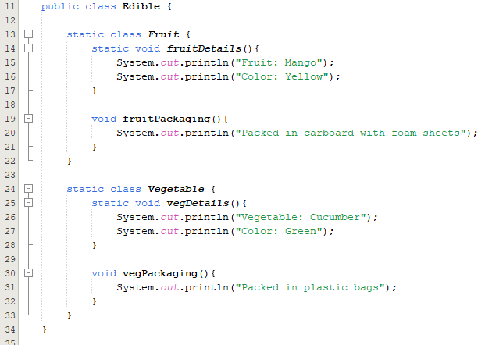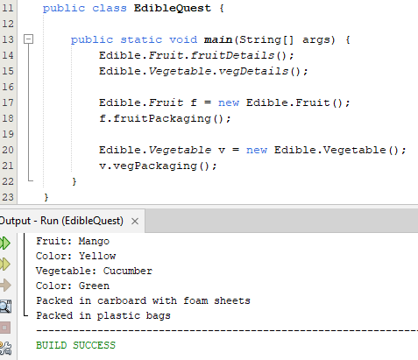

Create three different minMaxAdd()………….real numbers and characters.
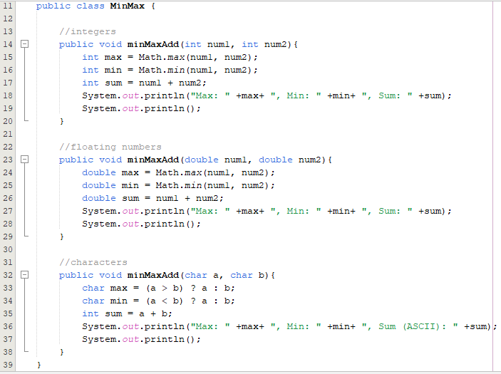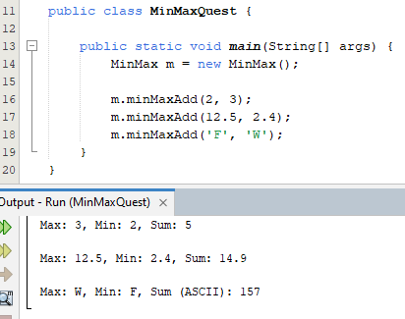

Create a class ObjectOriented………….. JavaLanguage class to access all of its own and parent’s methods.

Also

In previous question, create a new class C++……….access all of its own and parent’s methods.
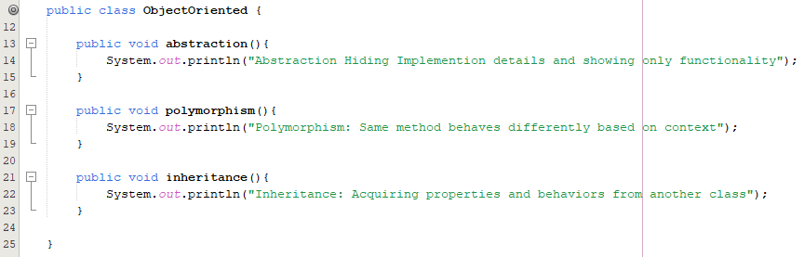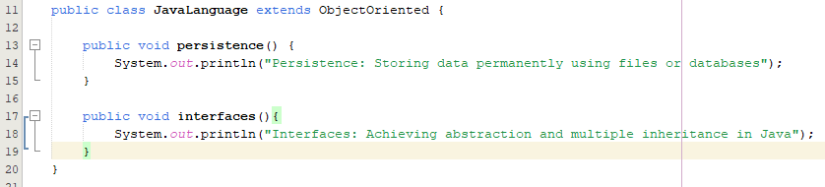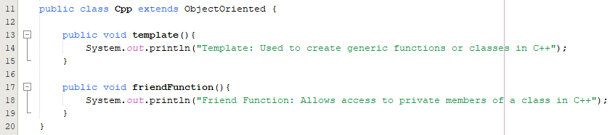
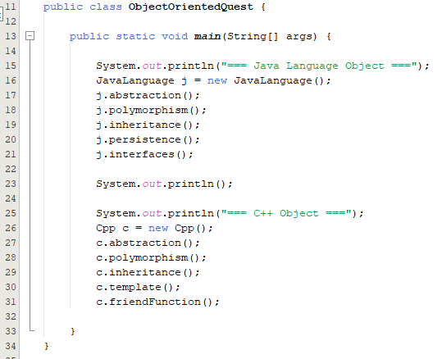
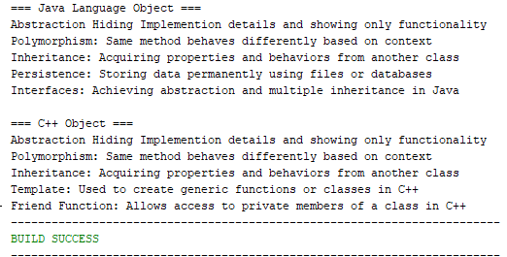

Create class University……………..Department class to Display() method and University ranking.

Create a class Employee………………..employee’s name, ID, salary details, and joining date.
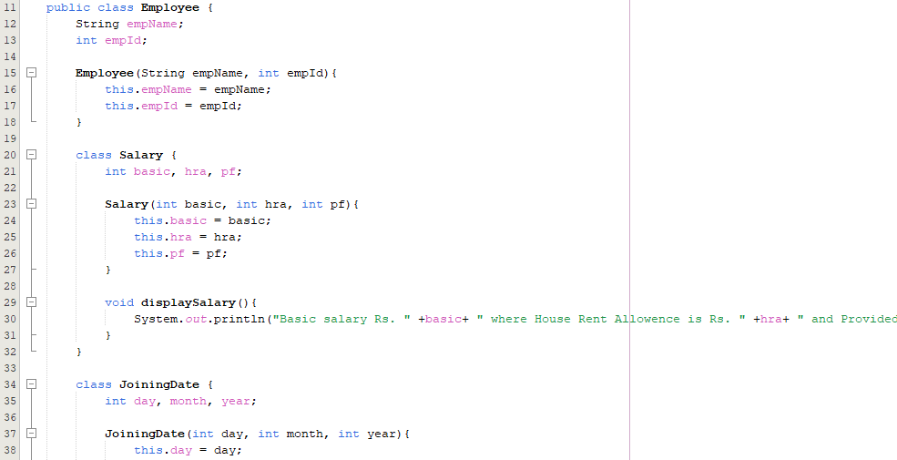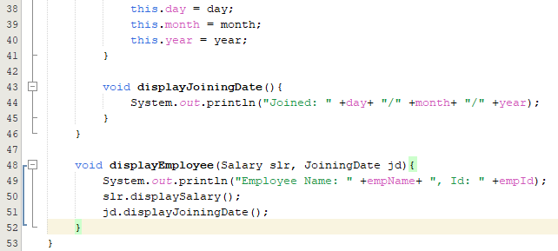
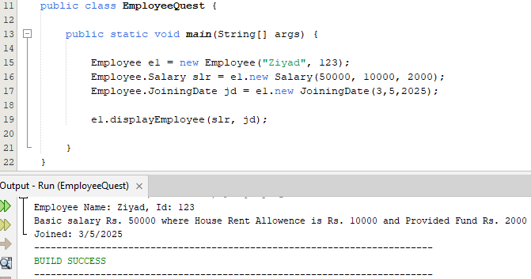

Create a class Shape………….calculates area of a circle.
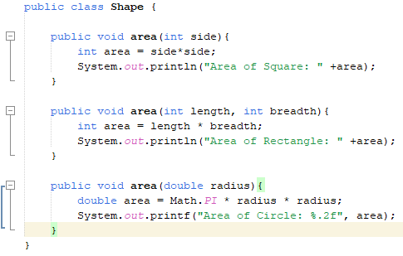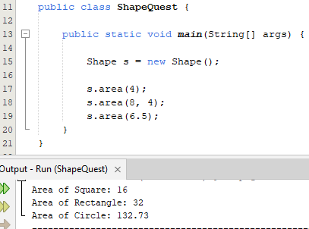

Create a class Vehicle……………….of Vehicle to call run() for objects of Bike and Car.
